CR-05 - Goals and Outcomes
Progress the jurisdiction has made in carrying out its strategic plan and its action plan. 91.520(a)
This could be an overview that includes major initiatives and highlights that were proposed and executed throughout the program year.

In the 2017 program year the City of Round Rock continued to deliver programs and implement activities to achieve the goals and objectives described in the 2014-2018 Consolidated Plan and the 2017 Annual Action Plan. Per the table below the City is making progress towards meeting the goals identified but it is more important to remember that they are prone to some degree of undertainty, particularly in the number of units of measure and outcomes. Round Rock's plans outline three overarching goals: 1)To provide decent housing by preserving housing stock, increasing the availability of affordable housng and reducing discriminatory barriers 2)To provide a suitable living environment through safer, more livable neighborhoods 3)To expand economic opportunities through homeownership opportunities. Funding priorities and highlights for the 2017 Community Development Block Grant Program are listed below:
- Round Rock Area Serving Center Food Pantry Program expended all 2017 CDBG funds in the amount of $23,000 and assisted 878 low income households with food from their food pantry.
- Round Rock Area Serving Center Housing Assistance Program expended $22,536 in 2017 CDBG funds and served 228 low income households with rent or mortgage assistance with up to $100 per household.
- CASA Child Advocacy Program expended $21,000 of CDBG 2017 funds and assisted 82 abused or neglected children in court.
- Round Rock Housing Authority NOC Program expended $18,950 of CDBG 2017 funds and assisted 105 low income residents by providing teachers to mentor and tutor and with after school care and with a facilitator that assisted adult residents.
- The Hope Alliance Crisis Shelter project was also completed in the CDBG 2017 program year. CDBG funding from prior program years (14 & 15) were used for shelter improvements. Renovations included ADA accessible requirements, updated windows, insulation, flooring, kitchen and bathrooms and all other local government building requirements. During this program year 330 victims of domestic violence were assisted.
- CDBG program year 2016 funds were used to start Austin Avenue Sidewalks Improvements in program year 2017. The sidewalks were completed in the beginning of program year 2018.

Comparison of the proposed versus actual outcomes for each outcome measure submitted with the consolidated plan and explain, if applicable, why progress was not made toward meeting goals and objectives. 91.520(g)
Categories, priority levels, funding sources and amounts, outcomes/objectives, goal outcome indicators, units of measure, targets, actual outcomes/outputs, and percentage completed for each of the grantee’s program year goals.

Goal | Category | Source / Amount | Indicator | Unit of Measure | Expected – Strategic Plan | Actual – Strategic Plan | Percent Complete | Expected – Program Year | Actual – Program Year | Percent Complete
Affordable Housing: Minor Repairs and Modification | Affordable Housing | CDBG: $ | Homeowner Housing Rehabilitated | Household Housing Unit | 25 | 15 | 60.00% | 5 | 4 | 80%
Neighborhood Improvement: RRASC Clean-up | Neighborhood clean-ups | CDBG: $ | Other | Other | 1000 | 455 | 45.50% | 0 | 0 | 0
Public Facility and Infrastructure Improvements | Non-Housing Community Development | CDBG: $ | Public Facility or Infrastructure Activities other than Low/Moderate Income Housing Benefit | Persons Assisted | 1500 | 1 | 0.07% | 3630 | 0 | 0.00%
Public Facility and Infrastructure Improvements | Non-Housing Community Development | CDBG: $ | Public Facility or Infrastructure Activities for Low/Moderate Income Housing Benefit | Households Assisted | 0 | 0 | 0 | 0 | 0 | 0
Public Facility Imp.: Domestic Violence Shelter | Non-Housing Community Development | CDBG: $ | Public Facility or Infrastructure Activities other than Low/Moderate Income Housing Benefit | Persons Assisted | 1 | 1 | 100.00%
Public Facility Imp.: Domestic Violence Shelter | Non-Housing Community Development | CDBG: $ | Other | Other | 1 | 1 | 100.00%
Public Services: After School Tutoring | Public Services | CDBG: $ | Public service activities other than Low/Moderate Income Housing Benefit | Persons Assisted | 350 | 140 | 40.00% | 100 | 105 | 105.00%
Public Services: CASA Child Advocacy |  | CDBG: $ | Public service activities other than Low/Moderate Income Housing Benefit | Persons Assisted | 285 | 1256 | 440.70% | 100 | 82 | 82.00%
Public Services: Food Banks | Public Services | CDBG: $ | Public service activities other than Low/Moderate Income Housing Benefit | Persons Assisted | 4200 | 1874 | 44.62% | 850 | 878 | 103.29%
Public Services: Food Banks | Public Services | CDBG: $ | Public service activities for Low/Moderate Income Housing Benefit | Households Assisted | 0 | 0 | 0 | 0 | 0 | 0
Public Services: Housing Assistance | Affordable Housing | CDBG: $ | Public service activities for Low/Moderate Income Housing Benefit | Households Assisted | 1000 | 501 | 50.10% | 250 | 228 | 91.20%
Public Services: Meals on Wheels |  | CDBG: $ | Public service activities other than Low/Moderate Income Housing Benefit | Persons Assisted | 1000 | 502 | 50.20% | 0 | 0 | 0
Table 1 - Accomplishments – Program Year & Strategic Plan to Date

Assess how the jurisdiction’s use of funds, particularly CDBG, addresses the priorities and specific objectives identified in the plan, giving special attention to the highest priority activities identified.
All of the funds expended during the program year directly addressed the priorities and objectives identified in the 2014-2018 Five Year Consolidated Plan and the 2017 Annual Action Plan. Funding decisions were based on the following process:
Citizen Participation: During the development of the CDBG 2017 plan, the City held two public hearings to solicit input from residents and social service providers in Round Rock. The public hearings were advertised in the local newspaper in English and Spanish as well as posted on the City Hall Bulletin and the City website. The public hearings were held at the Round Rock City Hall Council Chambers which is accessible to persons with disabilities. The City is committed to compliance with the Americans with Disabilities Act and Section 504 of the Rehabilitation Act of 1973, as amended. Reasonable modifications and equal access to communications will be provided upon request for the public hearings. City staff was present at all public hearings and was available to translate for persons with Limited English Proficiency.
Funding Caps: the City obligated the full 20% for program administration and the full 15 % for public services.
In addition to funding caps and meeting a High Priority need, the City considered other federal requirements in order to fund an activity. Activities had to meet a National Objective: 1) Benefit low to moderate income persons; 2) Prevent Slum or Blight or 3) Meet an urgent need.
Utilizing these needs and objectives, a CDBG application process was undertaken to identify non-profit groups and city departments that could address the objectives. Successful applicants were awarded CDBG grant funding to undertake programs and projects that addressed the needs, priorities and specific needs identified in the plan. A detailed breakdown of the CDBG funds awarded and accomplishments reported for each activity funded is available in the PR03 Actitivity Summary Report available as Attachment 2 to this document.

CR-10 - Racial and Ethnic composition of families assisted
Describe the families assisted (including the racial and ethnic status of families assisted). 91.520(a)

 | CDBG
White | 866
Black or African American | 359
Asian | 20
American Indian or American Native | 6
Native Hawaiian or Other Pacific Islander | 1

Total | 1,252

Hispanic | 467
Not Hispanic | 785

Table 2 – Table of assistance to racial and ethnic populations by source of funds

Narrative
The table above is labeled families assisted, however, the data is reporting on both families and persons assisted.
As demonstrated in the table above, for CDBG, 30% of those assisted were racial minorities, and 38% were Hispanic.
This table does not include all ethnicities and Other/Multi-racial like it is broken down in the IDIS Actual Accomplishments reporting page so numbers are actually a bit higher than shown in the table above. A detailed breakdown of the CDBG funds awarded and accomplishments reported for each activity funded is available in the PR03 CDBG Activity Summary Report, available as Attachment 2 to this document.

CR-15 - Resources and Investments 91.520(a)
Identify the resources made available
Source of Funds | Source | Resources Made Available | Amount Expended During Program Year
CDBG | CDBG | 605,539 | 544,822
HOME | HOME
HOPWA | HOPWA
ESG | ESG
Other | Other
Table 3 - Resources Made Available

Narrative
The amount of CDBG funds expended during the 2017 Program Year was $544,822.30 which included prior year funds that were allocated to infrastructure and housing programs. At the end of the program year the City of Round Rock CDBG Program met the timeliness spending ratio of 1.49 as required by HUD. The following is the amount expended per Matrix Code Category:
14A Single Family Rehab (Habitat for Humanity): $11,447.01
03C Homeless Faciities (Hope Alliance): $163,560
03F Park, Recreational Facilities (City of Round Rock Veterans Park) $37,063.68
03L Sidewalks (Austin Avenue Sidewalks) $128,412.85
05 Public Services (RRHA Neighborhood Outreach Center) $18,950
05N Abused and Neglected Children (CASA) $21,000
05Q Subsistence Payment (RR Area Serving Center-Housing Asst.) $22,536
05W Food Banks (RR Area Serving Center-Food Pantry) $23,000
21A General Program Administration $118,852.76

Identify the geographic distribution and location of investments
Target Area | Planned Percentage of Allocation | Actual Percentage of Allocation | Narrative Description
Table 4 – Identify the geographic distribution and location of investments

Narrative
All activities were made available to eligible participants on a city-wide basis who met the requirements of a low to moderate income person and/or household. A large portion of the federal funds are designated for public facility improvements in low-income neighborhoods. The CDBG program does not have any designated target areas but the following "High Priority" need activities describe the geographic distribution used:
Single Family Rehabilitation-Habitat for Humanity: The geographic distribution was city wide.
Public Services: The geographic distribution was city wide.
Infrastructure and Facility Improvements: The geographic distribution was a low to moderate income areas.
All projects funded were identified as “High Priority” in the Five Year Consolidated Plan (2014-2018). All CDBG funds (100%) were obligated to projects that benefit low to moderate income residents and all projects met a national objective.
During the 2016-2017 Program Year the City of Round Rock did not fund any activities that did not meet a National Objective or that required Anti-displacement or Relocation.

Leveraging
Explain how federal funds leveraged additional resources (private, state and local funds), including a description of how matching requirements were satisfied, as well as how any publicly owned land or property located within the jurisdiction that were used to address the needs identified in the plan.
In an effort to leverage funds, the City has combined the CDBG and General Fund social service funding process. By combining these two processes, we can make sure to fund agencies providing a high priority need with General Funds that could not be funded with CDBG funds due to the 15% funding cap. This also eliminates the duplication of services. The process of funding social service agencies is as follows: A team consisting of Council members, City finance staff and CDBG staff review agency applications using set criteria and performance measurement. Funding recommendations are presented to the City Council through the budget process. Awarded agencies are contracted to deliver the specific services to residents of Round Rock. In 2017-2018 in addItion to funding the full 15% in public services the City of Round Rock also funded the following agencies with General Funds to provide services for a total amount of $182,000:
- Literacy Council-GED/ESL/Literacy classes $5,000
- Foundation Communities, Inc.-Free tax preparation for low income residents $15,000
- YMCA-After school care scholarships for low income families $15,000
- Round Rock Area Serving Center-Volunteer Center Coordinator Salary $35,000
- Senior Access-door to door senior transportation $30,000
- Hope Alliance-Counselor salary $40,000
- Texas Baptist Children's Home-partial salary for Trust Based Relational Untervention Specialist $10,000
- Williamson County Children's Advocacy Center-child abuse intervention $32,000
The City of Round Rock did not fund any city owned facilities for program year 2017.

CR-20 - Affordable Housing 91.520(b)
Evaluation of the jurisdiction's progress in providing affordable housing, including the number and types of families served, the number of extremely low-income, low-income, moderate-income, and middle-income persons served.

 | One-Year Goal | Actual
Number of Homeless households to be provided affordable housing units | 0 | 0
Number of Non-Homeless households to be provided affordable housing units | 0 | 0
Number of Special-Needs households to be provided affordable housing units | 0 | 0
Total | 0 | 0
Table 11 – Number of Households

 | One-Year Goal | Actual
Number of households supported through Rental Assistance | 250 | 228
Number of households supported through The Production of New Units | 0 | 0
Number of households supported through Rehab of Existing Units | 5 | 4
Number of households supported through Acquisition of Existing Units | 0 | 0
Total | 255 | 232
Table 12 – Number of Households Supported

Discuss the difference between goals and outcomes and problems encountered in meeting these goals.
The City was a bit short of meeting the proposed goal of providing rental assistance with CDBG funds to 250 low to moderate income unduplicated households by funding the Round Rock Area Serving Center Housing Assistance Prgram as a public service. The Round Rock Area Serving Center did assist 228 unduplicated clients with the $25,000 in CDBG funds to provide rental asssistance through their Housing Assistance Program. Habitat for Humanity was funded with CDBG funds to provide minor home repair under affordable housing and will continue to provide home repair to the low to moderate income residents of Round Rock. The city of Round Rock has no numbers or data to report on the goals and actuals on Table 5 for homeless households, non-homeless households or special needs households. These goals were not a part of the 2017 Annual Action Plan.

Discuss how these outcomes will impact future annual action plans.
The City of Round Rock will continue to provide minor home repair in the next program year with 2018 CDBG funds. Single family rehabilitation is identified as a "High" priority need in the 2014-2018 Consolidated Plan, therefore Round Rock will continue to fund home repair projects. Habitat for Humanity and the City of Round Rock are working together to meet current goals.
In addition to funding minor home repair the City will continue to fund the Round Rock Area Serving Center for housing assistance.

Include the number of extremely low-income, low-income, and moderate-income persons served by each activity where information on income by family size is required to determine the eligibility of the activity.

Number of Households Served | CDBG Actual | HOME Actual
Extremely Low-income | 4 | 0
Low-income | 0 | 0
Moderate-income | 0 | 0
Total | 4 | 0
Table 13 – Number of Households Served

Narrative Information
The number of extremely low, low and moderate income households listed in the table above are only for the Habitat for Humanity housing program discussed in this section. The PR03 report in Attachment 2 goes into detail on the income of households/persons served for every activity including public services where information by family size is required to determine eligibility.
In the efforts to address "worst case needs and persons with disabilities" the City funds the Round Rock Area Serving Center (RRSC) with CDBG funds and general funds. The RRASC assists the very low income, persons with disabilities and homeless or people that are stranded in the city with food and/or rent or temporary shelter and gas.
The City of Round Rock recognizes that the very low income, and persons with disabilities may have difficulty paying their utiltiy bills when facing financial difficulties. In addition to funding the RRASC to provide rent and food assistance the city works with the RRASC to offer the Friendly Rock Program. The Friendly Rock Program helps round rock residents facing financial difficulties pay their essential water utility services. This program is funded with resident donations and is administered for the City by the RRASC. Water customers that want to contribute to this program simply complete the Contribuition Form in their utility bill that authorizes the city to add $1 or more to their utility bill payment each month.
In order to foster and maintian affordable housing, the City of Round Rock supports affordable housing tax credit developments. Although the City of Round Rock does did not invest CDBG funds in providing non-homeless but very low income residents with affordable housing units, there are several Low Income Housing Tax Credit multi family housing units available to very low income families in Round Rock. The Red Villas, Townhomes at Double Creek and Waters at Sunrise are affordable multi family developments constructed by residential developers or investors with tax credits through the Texas Department of Housing and Community Affairs. Using the Housing Tax Credit program these developers were able to construct affordable housing units that are decent, safe and sanitary to low and very low income residents. Earlier this year the Round Rock city council approved a resolution in support of developers application for the state tax credit program to make major renovations at the Round Rock Oak Grove multi family housing complex. The Texas Department of Housing and Community Affairs has since announced that they have approved an allocation of housing tax credits for the Round Rock Oak Grove renovation project. Renovation was set to start March 2018.
The City is making progress towards meeting the needs of persons with disabilities by funding park improvements for the addition of ADA transition ramp into the playground, replacing deficient paths and walkways and deficient curb ramps; construction of new sidewalks include new ADA accessible curb ramps, driveway modifications to existing driveways that currently exceed a 2% cross-slope where the travel path is located, and new sidewalk connections where none previously existed.

CR-25 - Homeless and Other Special Needs 91.220(d, e); 91.320(d, e); 91.520(c)
Evaluate the jurisdiction’s progress in meeting its specific objectives for reducing and ending homelessness through:
Reaching out to homeless persons (especially unsheltered persons) and assessing their individual needs
The City's efforts to prevent homelessness is referring citizens to organizations who address the homelessness issue that affect their quality of life such as Round Rock ISD, Round Rock Area Serving Center, and the Sacred Heart Community Clinic. This strong referral system has strengthened the relationship with these organizations.
Other efforts to prevent homelessness, include the continued funding of public services that provide services to assist low-income households improve their abilities for self-sufficiency; and providing on-going technical assistance to local service providers to increase their organizational capacity and ability to provide effective services.
Round Rock ISD
Round Rock ISD has a Homeless Liaison that assists homeless and at risk homeless students as well as administers a Texas Suport for Homeless Education Program (TEXSHEP).
The Homeless Liaison provides the following:
- Verify and track students
- Coordinate services for homeless students
- Works with campuses to make sure students are receiving academic support
- Coordinates with transportation and food services to ensure transportation and breakfast/lunch for students
TexShep funds are also used to provide school supplies and emergency clothes and food as well as summer school credit recovery tuition.
Round Rock Area Serving Center
The Round Rock Area Serving Center provided housing assistance to low income residents of Round Rock with 2017 CDBG funds. This program allows the Round Rock Area Serving Center to help with rent or mortgage to help prevent eviction or foreclosure. The Round Rock Area Serving Center also provides temporary non CDBG funded lodging for homeless persons and assists them with food, clothing, prescription assistance, gas vouchers, blankets and bus tickets. Last program year the Round Rock Area Serving Center provided temporary shelter 28 times, issued out 41 gas vouchers and provided transportation 17 times for homeless in Round Rock.
Sacred Heart Community Clinic
The Sacred Heart Community Clinic in Round Rock assist homeless persons with health care. About 15 homeless persons received 45 free health care units of service from the clinic last program year. After an intake evaluation, they are provided free medical and dental care as well as free medications from their onsite pharmacy.

Addressing the emergency shelter and transitional housing needs of homeless persons
The City of Round Rock does not recieve any Emergency Solutions Grant funds and although CDBG did not fund any agencies to provide emergency shelter or transitional housing, the following agencies did provide these services in Round Rock during the CDBG 2017 program year with non-CDBG funds:
Hope Alliance Crisis Shelter provides emergency shelter to vicitms of domestic violence. Last program year they assisted 330 victims of domestic violence. Hope Alliance was provided general funds to pay for the salary of a counselor during the 2017 program year.
Bluebonnet Trails Supportive Housing program provides a safe and supportive program for adults in transition from crisis to stability while the individual resides in the program. The expected length of stay in the Supported Housing program is up to 90 days. At the end of the three month stay, participants will have increased resources for income, employment and sustainable residential stability.
The Bluebonnet Trails Suppoortive Housing Program accepts applications from interested individuals who are homeless or at risk of homelessness. Each application is reviewed by the housing committee to determine enrollment into the program. The transitional homes are tobacco, alcohol, and drug free and encourage spiritual, mental and emotional growth.
The goal of the Supportive Housing Program is to facilitate the change process for individuals with substantial mental illness through skills building, self-awareness, self-advocacy, and providing supports necessary for stable lives in a community setting. While in the home setting, individuals will receive the following services:
- Skills Building
- Peer Support
- Supported Employment
- Referrals and Education

Helping low-income individuals and families avoid becoming homeless, especially extremely low-income individuals and families and those who are: likely to become homeless after being discharged from publicly funded institutions and systems of care (such as health care facilities, mental health facilities, foster care and other youth facilities, and corrections programs and institutions); and, receiving assistance from public or private agencies that address housing, health, social services, employment, education, or youth needs
In an effort to help low income residents of Round Rock including those that are likely to become homeless or are currently homeless, the City of Round Rock 2017 CDBG funding was awarded to the Round Rock Area Serving Center for the purchase of food to stock their food pantry and also funds to assist residents with rent and mortgage payments. Because the Round Rock Area Serving Center does not turn anyone away they are probably the main source of assistance in the city for all extremely low income families and individuals at-risk of becoming homeless including those likely to become homeless after being discharged from publicly funded institutions and systems of care.
In addition to assisting low-income individuals and families with CDBG funded rent/mortgage payments and food they also provide the following non-CDBG funded services to help these families and individuals avoid becoming homeless:
- Prescription assistanceVouchers to the thrift store for clothes and furniture
By providing these resources, a family can pay their rent and mortgage when facing difficult times. Often the loss of a job or an illness may cause a family to fall behind in the rent or mortgage in order to buy food or prescriptions.

Helping homeless persons (especially chronically homeless individuals and families, families with children, veterans and their families, and unaccompanied youth) make the transition to permanent housing and independent living, including shortening the period of time that individuals and families experience homelessness, facilitating access for homeless individuals and families to affordable housing units, and preventing individuals and families who were recently homeless from becoming homeless again
In an effort to assist homeless persons and families with children the following agencies provided services or housing with non-CDBG funded programs:
The Texas Baptist Children's Home
The Texas Baptist Children's Home (TBCH) provides transitional housing to mothers and their children. Family Care is a place for motivated mothers and their children to live while they transition into successful, independent futures.
The ministry has nine cottages, housing up to five families in each cottage, with live-in Family Life Coordinators. Each unit has a bedroom, bathroom, and kitchen areas, and families share large dining, living, laundry and play space.
A staff therapist offers individual, group and family therapy for every mother and child, as needed.
Assistance is provided in goal setting, education, budgeting, parenting, effective communication, relationship building and spiritual growth. As the residents buy-in, they must commit to being gainfully employed and saving toward future stability.
The Texas Baptist Children's Home (TBCH) provides transitional housing to mothers and their children. Family Care is a place for motivated mothers and their children to live while they transition into successful, independent futures.
City staff networks with the TBCH and the city also plans to include the TBCH to participate in the needs assessment and one on one interviews for the completion of the next 5 year consolidated plan and the analysis of impediments to fair housing stakeholder meetings.
Wiliamson-Burnet Counties Opportunities (WBCO)
During the program year, Williamson-Burnet Counties Opportunities (WBCO) provided childcare for five children from four families that were homeless. During the program year the families were able to acquire housing.
During the 2017 program year city CDBG staff did not network or know of any agencies in Round Rock that assisted homeless veterans and unaccompanied youth. CDBG staff will continue to network with non-profits and report on the resources that are available in Round Rock for the homeless population.

CR-30 - Public Housing 91.220(h); 91.320(j)
Actions taken to address the needs of public housing
Public housing is administered and managed by the Round Rock Housing Authority. The Round Rock Housing Authoirty was established in 1966, with the first development built in 1972. Today the Housing Authority owns 100 units at the following three locations: 1505 Lance Lane, 1100 Westwood and 1007 Cushing Drive. The housing authority also administers Section 8 Housing Vouchers. During the 2017 program year the housing authority administered 212 housing vouchers.
The Round Rock Housing Authority received approximately $164,846 in Capital Grant Funds that were used for operations during the 2017 program year.
In an effort to address and improve the needs of public housing and resident initiatives the City of Round Rock funded the Round Rock Housing Authority (RRHA) Neighborhood Outreach Center (NOC) Program. The RRHA partnered with the Round Rock ISD to employ retired educators to tutor/mentor elementary and secondary children after school at the NOC. CDBG program year 2017 funding was used to pay for the partial salaries of teachers and a resident facilitator. The facilitator worked with resident families and was the community link to education. By implementing a reading program for the afterschool tutoring program, the facilitator has noticed improvements in reading levels with the children that attended the NOC.

Actions taken to encourage public housing residents to become more involved in management and participate in homeownership
The Round Rock Housing Authority continued the Family Self Sufficiency (FSS) Program in the 2017-2018 program year. The FSS program was created to help housing residents become more involved in management and participate in homeownership. Through the FSS Program families received supportive case management to help them reach their individual goals towards self-sufficiency. Some of the classes that the FSS program provides are:
- Banking Basics
- Budgeting Workshops
- Wellness
- Financial Literacy
- Financial Recovery
- Pay Yourself First
- Own Your Own Home
- Credit Repair
- Borrowing Basics
During the 2017-2018 program year a RRHA tenant that participated in the FSS program was able to purchase a home. Other tenants are currently still working on meeting their goals to help improve their lives.
Actions taken to provide assistance to troubled PHAs
The Round Rock Housing Authority continues to hold a "High Performer" status under HUD's Section Management Assessment Program (SEMAP); therefore, it is not designated as a "troubled" agency.

CR-35 - Other Actions 91.220(j)-(k); 91.320(i)-(j)
Actions taken to remove or ameliorate the negative effects of public policies that serve as barriers to affordable housing such as land use controls, tax policies affecting land, zoning ordinances, building codes, fees and charges, growth limitations, and policies affecting the return on residential investment. 91.220 (j); 91.320 (i)
In an effort to remove barriers to affordable housing the Round Rock City Council approved a resolution of support for a developer's application for state tax credits that would allow for major renovations to the Round Rock Oak Grove multi family housing complex. This fall the state announced that they have approved an allocation of housing tax credits for the Round Rock Oak Grove renovation project.
Council has also approved several Planned Unit Developments that allow for detached single family housing units on condominium lots. By providing this housing alternative to standard single family home on fee simple lots, developers are able to offer quality housing units at a lower price points due to reduced infrastructure and public improvement costs. These types of single family condominium developments are being recommended for infill or remnant tracts where larger scale residential developments would not be feasible.

Actions taken to address obstacles to meeting underserved needs. 91.220(k); 91.320(j)
Despite efforts, there remain a number of significant obstacles to meeting underserved needs. The following obstacles to meeting these needs in Round Rock are: Population growth; High cost of housing; Cut backs in state and federal funding for basic needs and the need to transportation to existing services and childcare exceed available resouces to meet these needs. To address the population growth and the high cost of housing, the Round Rock Area Serving Center provides rent/mortgage, food pantry and utility assistance. The City funded the RRASC for these programs with CDBG program year 17 funds.
The following programs also help address the cut backs in state and federal funding and the need for childcare and transportation to existing services:
Senior Access was provided General Fund money in the 2017 program year to provide door to door transportation to seniors to doctors appointments, pharmacies, grocery stores, to pay bills, and to social service agencies for services.
Foundation Community was awarded General Fund grant in program year 2017 to provide free tax preparation to low to moderate income families.
Meals on Wheels provides warm meals to homebound and congregate seniors year round.
Head Start provides affordable childcare to low income and homeless families.
In order to meet transportation demand, the city developed a fix route bus service that was designed and focused on access to employment services to meet the needs of the low income and minority populations to jobs, education and employment. This service offers ADA paratransit services as well for anyone with a disability that prevents them from being able to ride any fixed route vehicle, disembark from any fixed route vehicle or travel independently all or some of the time on any fixed route vehicle.
Council has also passed an ordinance that allows Round Rock Transit to sell discount bus passess to non-profit and government agencies for the purpose of distributing the passes to low income persons and families that meet the participation requirements.
The City also provides residents with the Guide to Affordable Housing in the Greater Austin Area. This guide is a tool for people seeking affordable rental housing in the Austin area that includes Round Rock. The guide contains general information on housing programs funded on the local, county, stte and federal levels, as well as specific information about complexes participating in these programs. It contains lists and explanations of rental housing with rent restrictions, income based rents and tenant income limits. The Guide to Affordable Housing is available at City hall and also a link to the guide is provided on the CDBG webpage on the City website.

Actions taken to reduce lead-based paint hazards. 91.220(k); 91.320(j)
During the CDBG 2017-2018 program year, the City of Round Rock continued its funding of CDBG grant funds to the Habitat for Humanity Minor Home Repair Program.
Because the majority of residential housing development in Round Rock occurred after the use of lead based paint was banned there are very few homes that receive minor home repair that were built before 1978 or that test positive for lead.
With the implementation of the Habitat for Humanity Minor Home Repair Program, the program policy and procedures manual addresses compliance with the Residential Lead Based Paint Hazard Reduction Act of 1992 (Title X) and subsequent changes in September 1999. The procedures include:
1. Notification
2. Identification
3. Treatment (if necessary)
The Habitat for Humanity Minor Home Repair Program funded with CDBG funds, aids in correcting substandard conditions which contribute to LBP hazards. Applicants who are eligible for the program are provided LBP information at the time of intake and were made aware of possible dangers of LBP.

Actions taken to reduce the number of poverty-level families. 91.220(k); 91.320(j)

During the 2017 program year the City of Round Rock took the following actions to reduce the number of poverty level families:
- Habitat for Humanity was funded with prior year CDBG funds to provide minor home repair for the low and very low income residents in Round Rock. A total of 4 households were assisted with repairs to include fence, plumbing, electrical, weatherization, and ADA improvements. This is an on-going project that will continue into program year 2018.
- Round Rock Area Serving Center was funded with CDBG program year 2017 to provide rent and mortgage assistance and access to their food pantry. A total of 1106 unduplicated low to moderate income Round Rock households received services with CDBG funds at the Serving Center.

Actions taken to develop institutional structure. 91.220(k); 91.320(j)
Executive implementation of the Consolidated Plan involves a varitey of agencies. Collaboration and coordination between agencies is important to ensuring that the needs in the community are addressed. The key agencies involved are described below:
- Williamson County and Cities Health District (WCCHD)-offers a variety of a services including alcohol and drug testing, WIC, family assistance, public health services, senior services, emergency services, and HIV testing and counseling.
- Round Rock Housing Authority (RRHA) administers the Housing Choice (Section 8) Voucher program. The City works closely with the RRHA regarding public housing issues.
- Habitat for Humanity of Williamson County provides residents with minor home repair.
- Wiliamson-Burnet Counties Opportunities (WBCO) provides meals to seniors.
- Senior Access provides door to door as needed transportation to seniors.
- United Way continues working with people and organizations throughout Williamson County to build stronger communities and improve lives.
Actions taken to enhance coordination between public and private housing and social service agencies. 91.220(k); 91.320(j)
The first Tuesday of every month the Round Rock Volunteer Center holds a networking meeting at the Alan R. Baca Senior Center. The City of Round Rock staff including CDBG staff, and sometimes representatives from Police, Fire, and code enforcement attend this meeting to make sure they are all up to date with social service agencies providing necessary resources for the low to moderate income, elderly, homeless and persons with disabilities. Representatives from non-profit and social service agencies come together to discuss community needs and to describe actions to reduce the number of persons living below poverty level. Every month a guest speaker talks about what their agency/organization is doing to address and reduce the number of persons living below poverty level. Ideas are exchanged and clients are referred to agencies that can help with their individual needs. Some of the agencies that attend these monthly meetings are:
- Surrounding Public Housing Authorities
- Literacy Council of Williamson County
- Hope Alliance
- American Red Cross
- Texas Workforce Commission
- Community Foundation
- Bluebonnet Trails MHMR
- WBCO
- Lifesteps
- RRISD
- United Way
- ARCIL (Advocacy Resource Center for Independent Living)
The City staff also works closely with the Round Rock Housing Authority to enhance coordination and build a strong relationship in order to assist the public housing residents. Because the City funds the Round Rock Housing Authority with CDBG funds, CDBG staff often meets with the housing authority director and makes frequent visits to the administrative offices.
The City will include all the agencies list above in the development of the next 5 year con plan and the development of the analysis of impediments to fair housing.
CDBG staff makes sure social service agencies are aware of the yearly CDBG funding process and all public hearings. CDBG staff used the Williamson County Networking Meeting as a platform to notify agencies of upcoming public heaings, action plans and funding opportunities.
The City of Round Rock Community Development Department Neighborhood Services staff work closely with neighborhoods to ensure that residents are aware of social service agencies that are available to provide much needed resources to the community. Neighborhood Services regularly attend neighborhood association meetings and one of the main goals is to enhance coordination between the public and city resources as well as social service agencies in the area.

Identify actions taken to overcome the effects of any impediments identified in the jurisdictions analysis of impediments to fair housing choice. 91.520(a)
In 2000, consultants from the University of Texas prepared an Analysis of Impediments to Fair Housing Round Rock, TX. This study provided a comprehensive review of the City’s administrative and judicial policies. The analysis profiled the housing market in Round Rock, identified the local market and addressed housing affordability, physical condition of housing stock, and public housing. Barriers to affordable housing that were identified through the city’s citizen participation process were:
- Lack of options
- Lack of transitional support and lack of assistance needed for move in costs/deposits
- Land prices
- Lack of community involvement and creativity in problem solving
- Negative neighborhood perception regarding low income housing
- Lack of public transportation
The City of Round Rock CDBG Program is currently working with the City of Austin, Round Rock Housing Authority, Travis County, Taylor Housing Authority, City of Pflugerville, Capital Area Council of Governments, Housing Authority of the City of Austin, Georgetown Housing Authority and Williamson County to develop a regional Analysis of Impediments to Fair Housing (AI). CDBG staff entered into a interlocal agreement with these other cities/housing authorities and hired a consultant to complete the Analysis of Impediments to Fair Housing (AI) in 2017. The AI is currently in draft form and public participation and comment period on the document will continue in early 2019. This AI will be sumitted to HUD in 2019 along with the next five year consolidated plan (2019-2023).
The City of Round Rock CDBG staff refers anyone needing to file a housing discrimination complaint or needing information on fair housing to the Austin Tenants Council. The Austin Tenants Council Fair Housing Program helps any person who has been discriminated against in the rental, sale, financing or appraisal of housing. The state and federal Fair Housing Act prohibits discrimination because of a person's race, color, national origin, religion, sex, disability (mental or physical) or familial status. The Fair Housing Program documents and investigates complaints; provides advice about remedies under fair housing laws, and coordinates legal services to assist victims of housing discrimination. The Fair Housing Program provides fair housing seminars and presentations to interested parties.

Fair Housing
In the meantime, the City funded the following CDBG and non-CDBG funded activities to implement and address the barriers to affordable housing and impediments to fair housing choice as identified in the public participation process during the development of the AI and/or affirmatively further fair housing for the protected classes: Race, Color, Sex, Religion, National Origin, Disability and Familial Status.Greenhil and Austin Avenue Sidewalks were funded with CDBG and project included new sidewalks, new curb ramps and the modification of existing driveways where the sidewalk path crossed the driveways.Veterans Park improvements was funded with CDBG and project included the replacement of an old restroom that had multiple ADA deficiencies, ADA transition ramp was added for acceess into the playground, and ADA deficient paths and walkways were also added. This project also included improved accessibility to the basketball court and picnic facilities.Greenhill Park was funded with CDBG funds project allowed for the replacement of deficient paths, curbs and walkways as well as added ADA transition ramp into the playground.Senior Access was funded with non-CDBG funds to assist elderly and disabled residents with door to door transportation to appointments and errands.

CR-40 - Monitoring 91.220 and 91.230
Describe the standards and procedures used to monitor activities carried out in furtherance of the plan and used to ensure long-term compliance with requirements of the programs involved, including minority business outreach and the comprehensive planning requirements
The City of Round Rock has developed a monitoring system that includes monitoring policies, procedures and standards to ensure that all activities carried out with CDBG funds are done so in a timely manner in accordance with federal monitoring requirements, and all other applicable laws, regulations, policies and sound management and accounting practices including all the requirements of 24 CFR 570.502, 2 CFR 200.238, 2 CFR 200.331 (d) and any other applicable federal requirements.
Subrecipients are monitored to ensure that they have implemented and administered their CDBG funded activities according to applicable Federal Requirements. Particular attention is paid to compliance with eligible and national objective requirements. Other areas emphasized are the financial management systems, interal controls, procurement practices and compliance with civil rights requirements.
When applicable, subrecipients are required to submit copies of paid receipts, timesheets, income documentation, client data and self-certification forms with their monthly requests for riembursement. This information is used to determine the number of unduplicated beneficiaries. Monthly reports werre submitted by each subrecipient so staff could monitor the progress of each activity, provide technical assitance or consultation when neded to ensure that all objectives are met.
Subrecipients are monitored on-site yearly. On-site monitoring will consist of a 5 step process:
1. Notification letter
2. Entrance conference
3. Documentation, Data Acquisition and Analysis
4. Exit Conference
5. Follow-up monitoring letter and report
The on-site monitoring will evaluate program administration and regulatory compliance to include the following:
- Conformance to the Subrecipient Agreement
- Record Keeping Systems
- Financial Management Systems
- Insurance
- Procurement Procedures
- Equipment
- Non-discrimination and Actions to Further Fair Housing
In the CDBG 2017-2018 program year the Round Rock Area Serving Center Food Pantry & Housing Assistance Program, CASA Child Advocacy Program and the Round Rock Housing Authority NOC Programs were monitored. The monitoring reviews revealed that their systems and procedures in the areas monitored were satisfactory.

Citizen Participation Plan 91.105(d); 91.115(d)
Describe the efforts to provide citizens with reasonable notice and an opportunity to comment on performance reports.
In order to provide citizens with a reasonable notice and an opportunity to comment on the CAPER, a Notice of Pubic Hearing was published in the Round Rock Leader on December 1, 2018 in English and Spanish. The notice was also posted on the City bulletin at city hall on November 30, 2018 as well as in the City news section of the website. The public hearing on the CAPER was held on December 20, 2018 before city council. The public was given 18 days to comment either in person or in writing. No comments were received. The draft CAPER was provided on the CDBG webpage on the city website as well as at city hall. The public hearings were held at City Hall Council Chambers which is accessible to persons with disabilities. The City is committed to compliance with the Americans with Disabilities Act and Section 504 of the Rehabilitation Act of 1973, as amended. Reasonable modifications and equal access to communications will be provided upon request for the public hearings. City staff was present at all public hearings and was available to translate for persons with Limited English Proficiency.

CR-45 - CDBG 91.520(c)
Specify the nature of, and reasons for, any changes in the jurisdiction’s program objectives and indications of how the jurisdiction would change its programs as a result of its experiences.
During the CDBG 2017-2018 Program Year there were no changes in the jurisdications program objections. The City of Round Rock did not have any open Brownfields Economic Development Initiative Grants (BEDI) during this program year therefore there are no BEDI accomplishments or program outcomes to report in this CAPER report.
Does this Jurisdiction have any open Brownfields Economic Development Initiative (BEDI) grants?
No
[BEDI grantees] Describe accomplishments and program outcomes during the last year.

CR-45 - CDBG 91.520(c)
Specify the nature of, and reasons for, any changes in the jurisdiction’s program objectives and indications of how the jurisdiction would change its programs as a result of its experiences.
During the CDBG 2017-2018 Program Year there were no changes in the jurisdications program objections. The City of Round Rock did not have any open Brownfields Economic Development Initiative Grants (BEDI) during this program year therefore there are no BEDI accomplishments or program outcomes to report in this CAPER report.
Does this Jurisdiction have any open Brownfields Economic Development Initiative (BEDI) grants?
No
[BEDI grantees] Describe accomplishments and program outcomes during the last year.

Attachment
Execuive Summary

Fourth Program Year CAPER

City of Round Rock CAPER 2017-2018

Executive Summary

The City of Round Rock received $605,539 in Community Development Block Grant funds in the Program Year 2017-2018. This was the fourth program year in the 2014-2018 Consolidated Plan. In this fourth program year, funds were allocated to public service activities, public facilities and improvements, and program administration.

The City obligated 20% ($121,107) of the total allocation to program administration and 15% ($90,830) to public services. The remaining $393,602 was allocated to Public Facilities and Improvements and Park Improvements.

In addition to expenditure caps, other federal requirements were considered to determine if a project was eligible for funding. Any project or activity must meet one of the following three National Objectives to be eligible [24 CFR § 570.200 (a)]: (1) to benefit low to moderate income persons; or (2) prevent slum and blight; or (3) to meet an urgent need (per HUD’s definition).

In the 2017-2018 Program Year the City of Round Rock expended $544822.30 in CDBG funds. These expenditures allowed the City of Round Rock to meet the timeliness test conducted by the HUD field office with a ratio of 1.49.

To ensure that the city would meet the spending ratio, the City of Round Rock required that Sub-recipients submit beneficiary reports and reimbursement requests on a monthly basis with all back up documentation. Staff conducted desk reviews every month to track their spending and performance goals.

In addition to that Sub-recipient agreements had an expiration date of July 1 to expend their funds. This stricter deadline ensured that sub-recipients spent funds in a timely manner.

The activities in the 2017-2018 Annual Action Plan met the criteria for funding and the CDBG program’s goals and objectives as well as the goal of reducing discriminatory barriers.

PR03 CAPER 2017
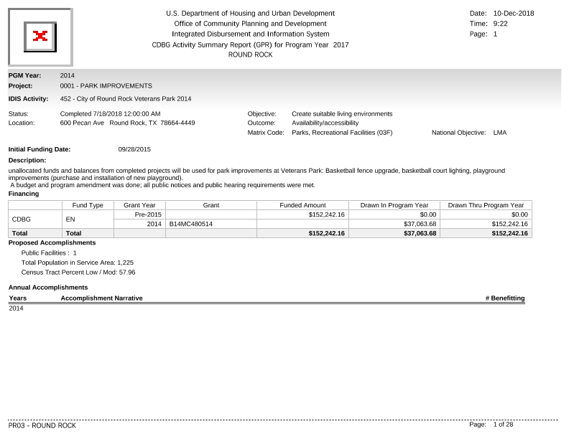
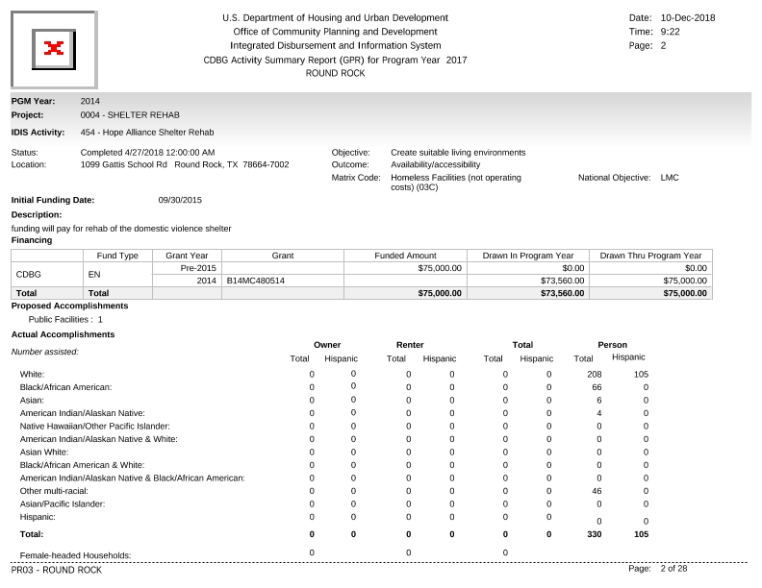
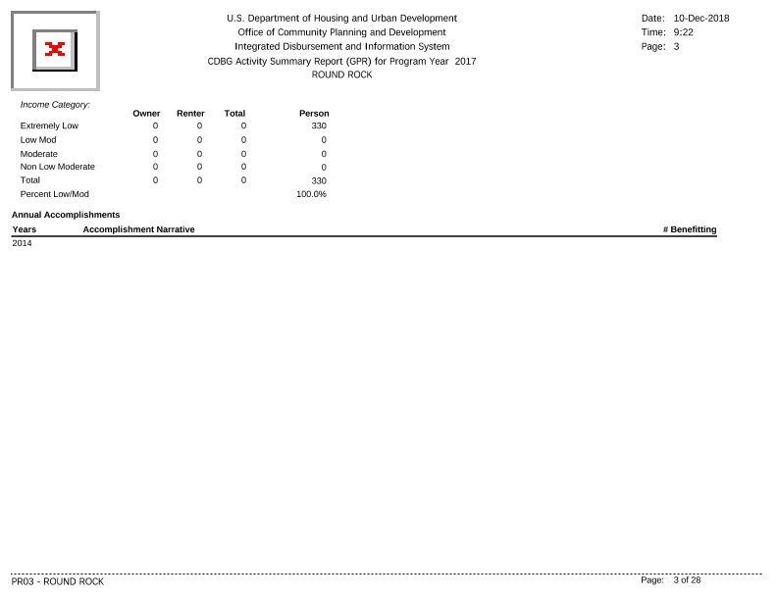
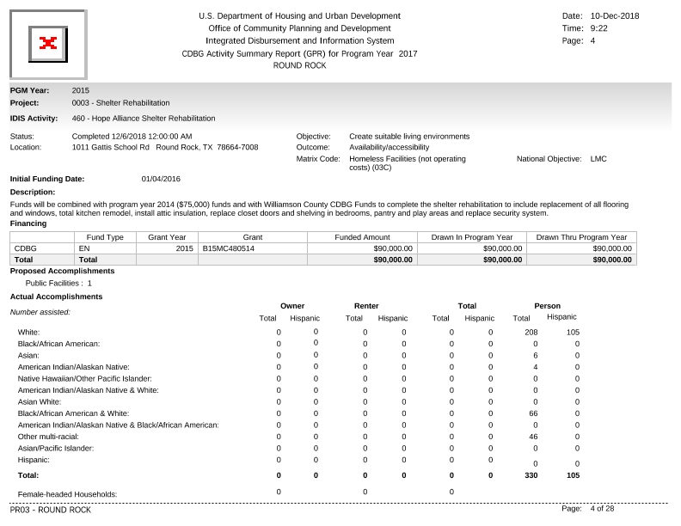
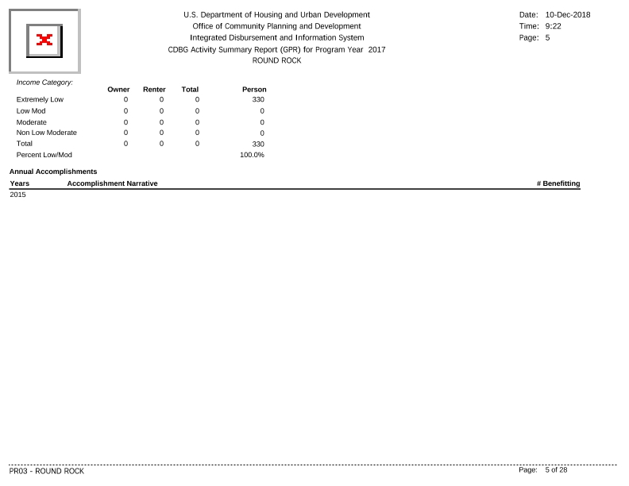
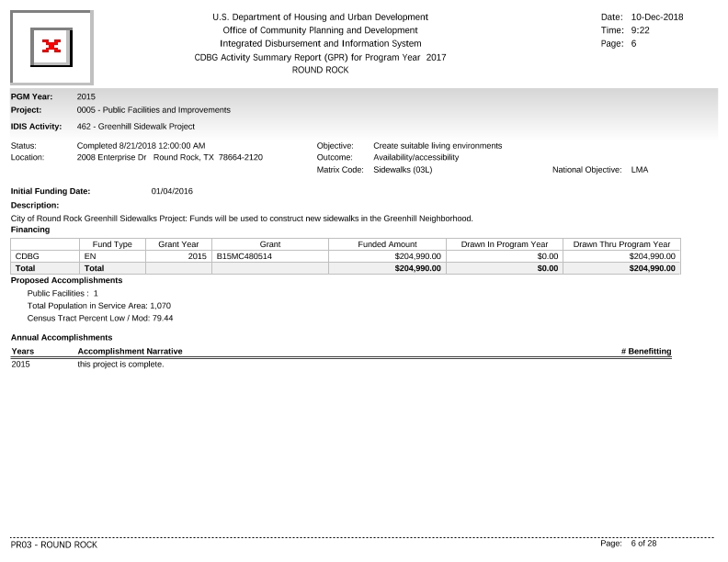
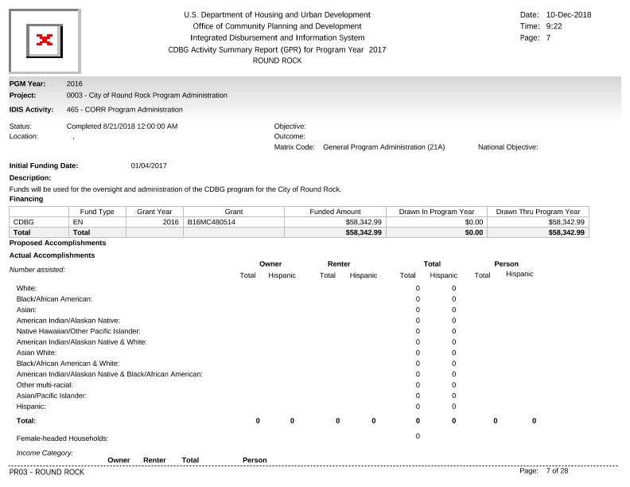
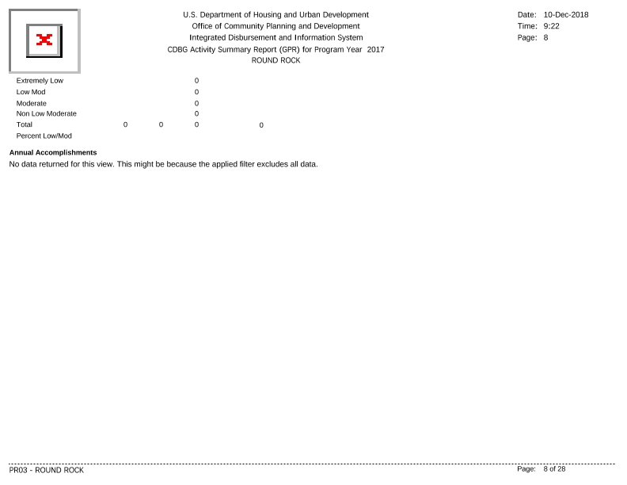
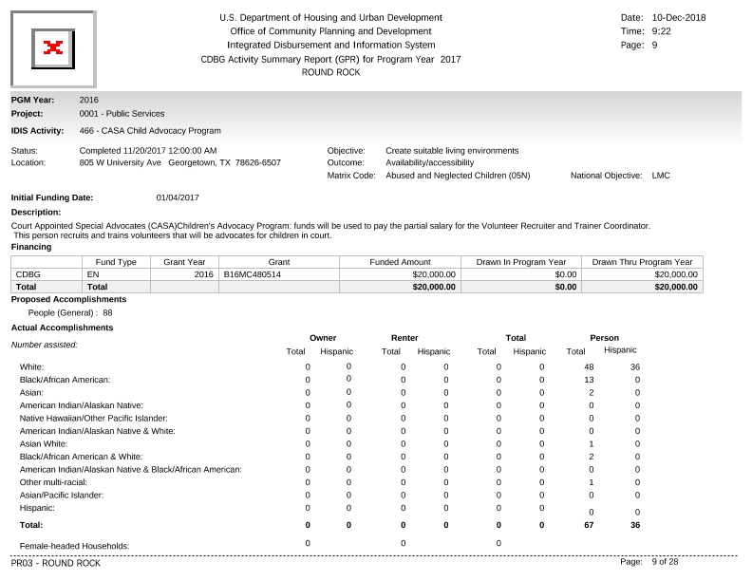
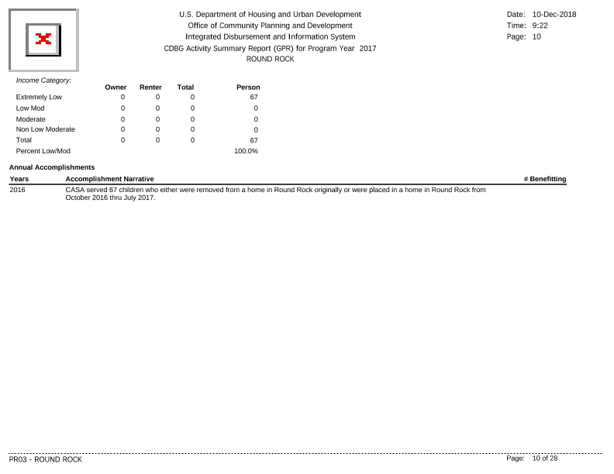
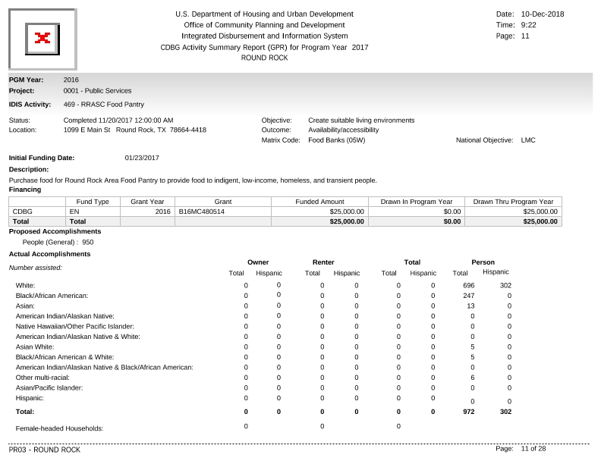
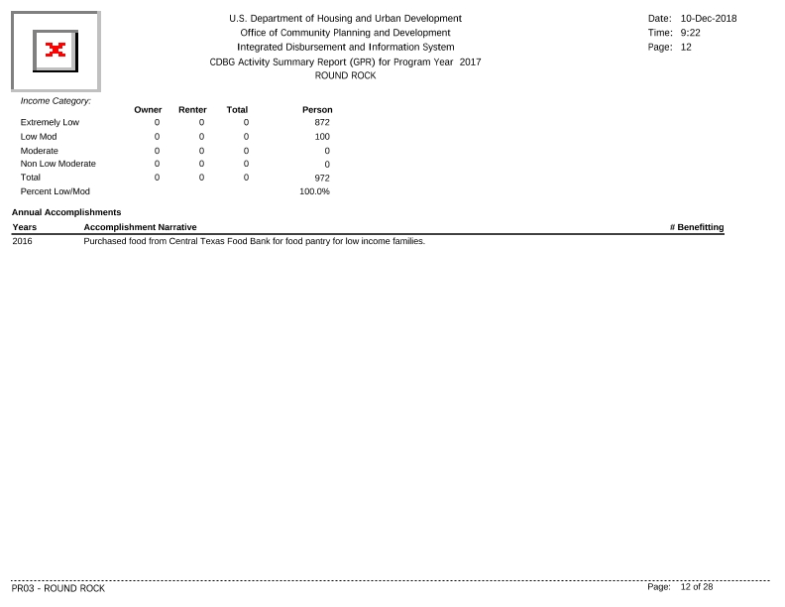
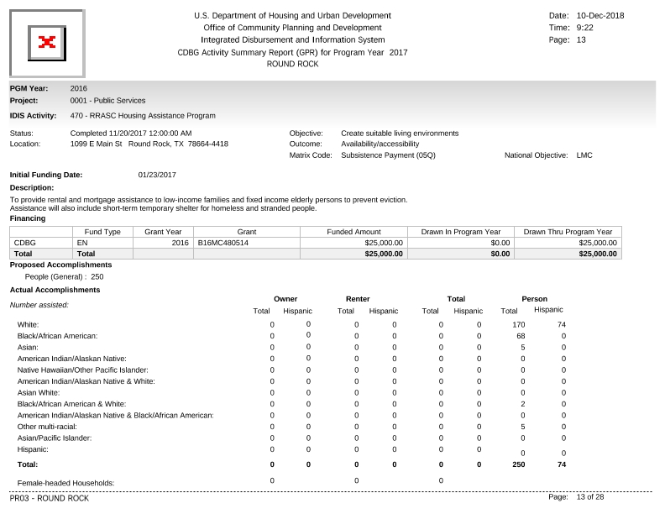
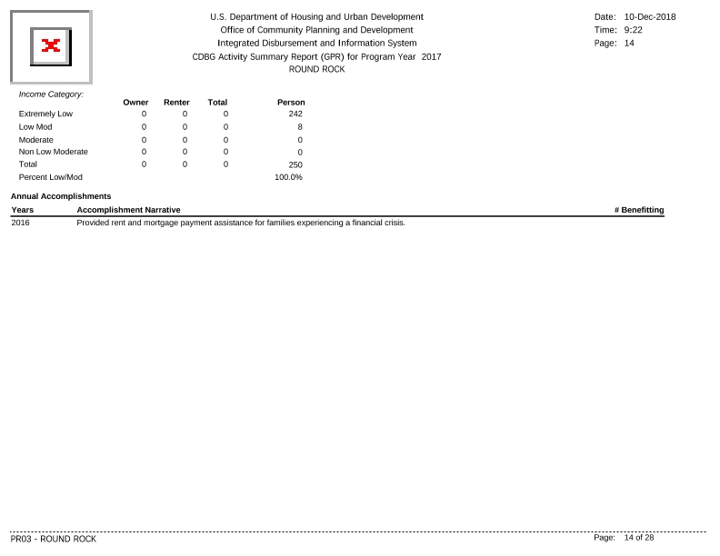
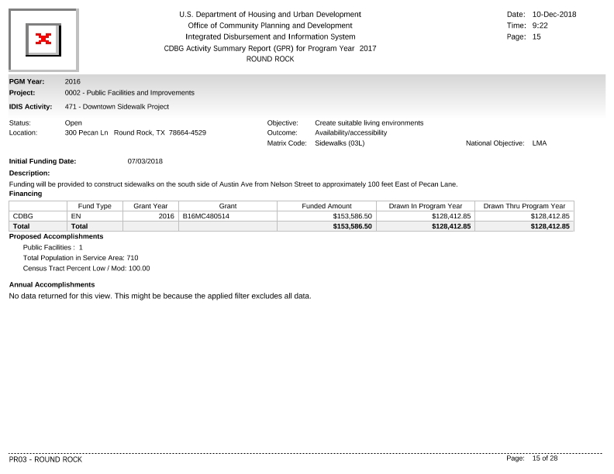
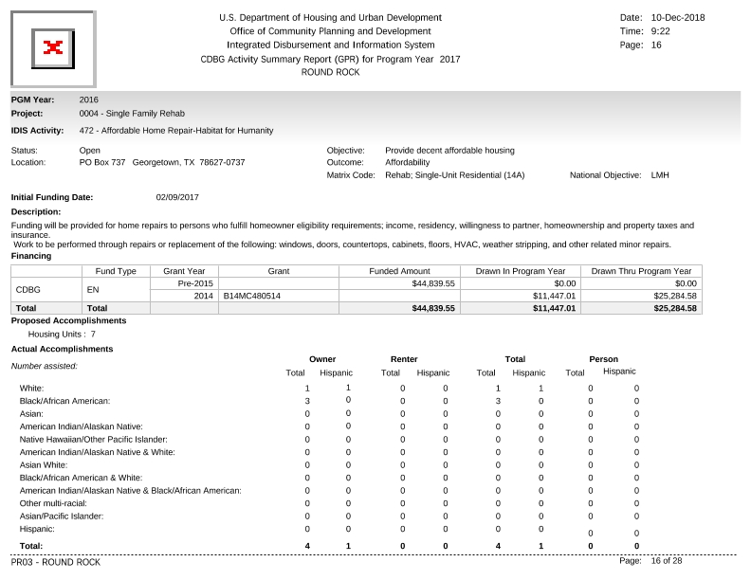
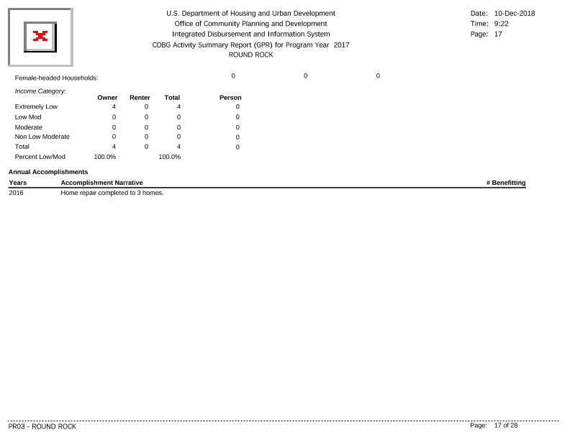
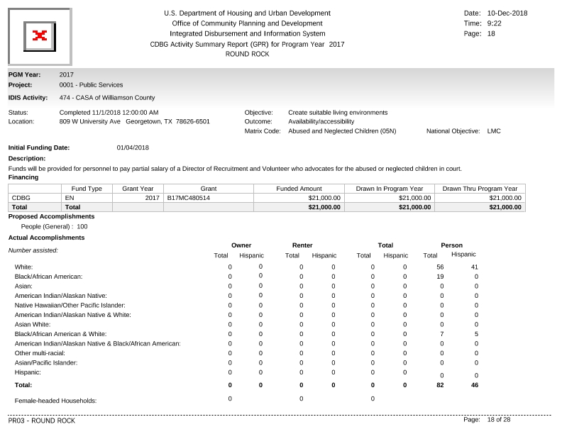
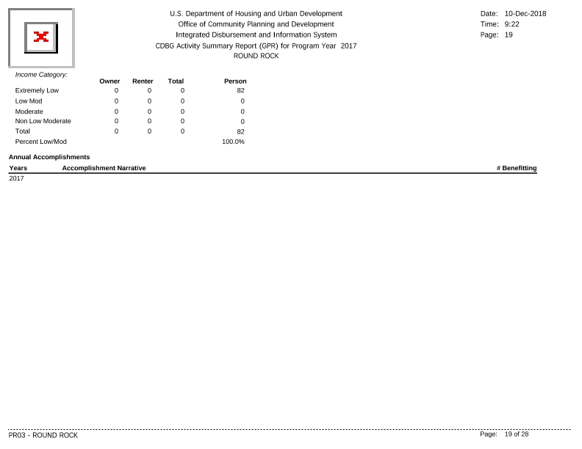
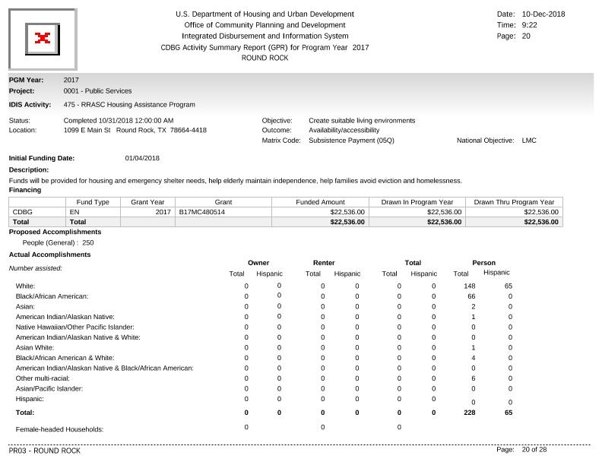
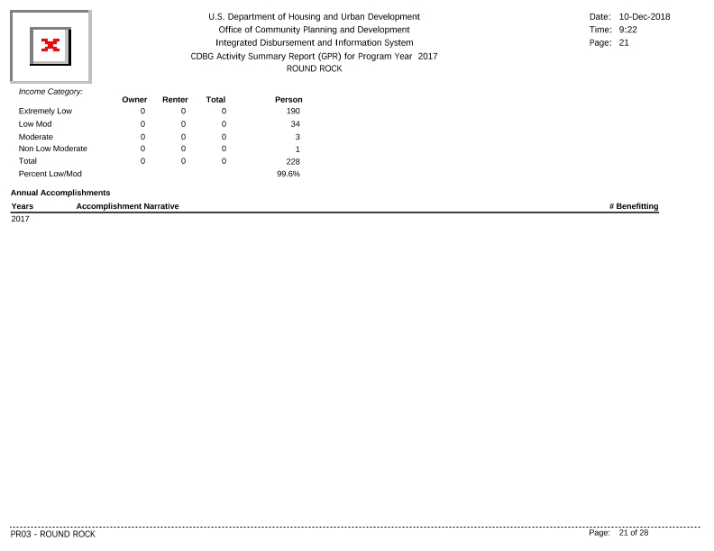
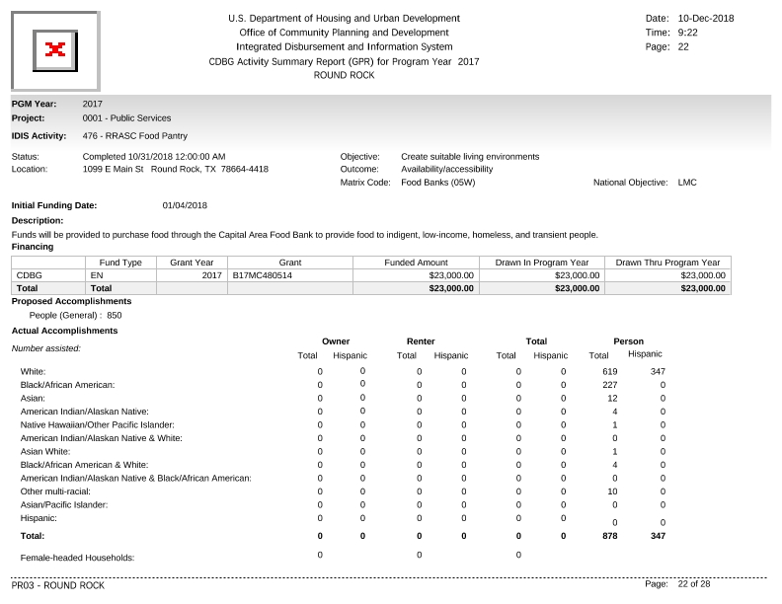
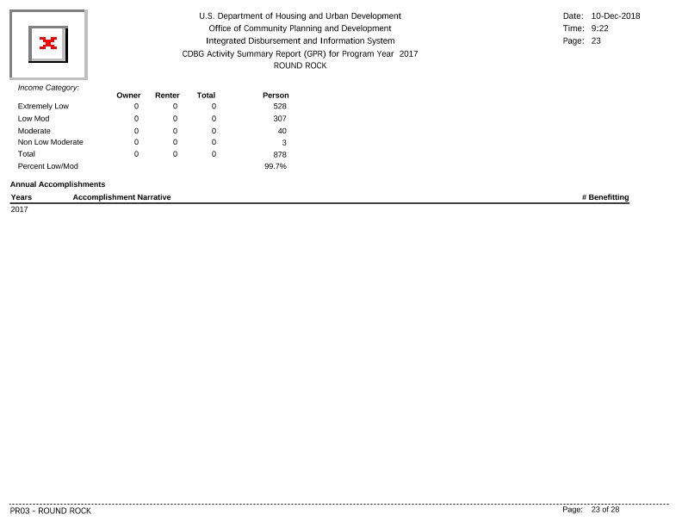
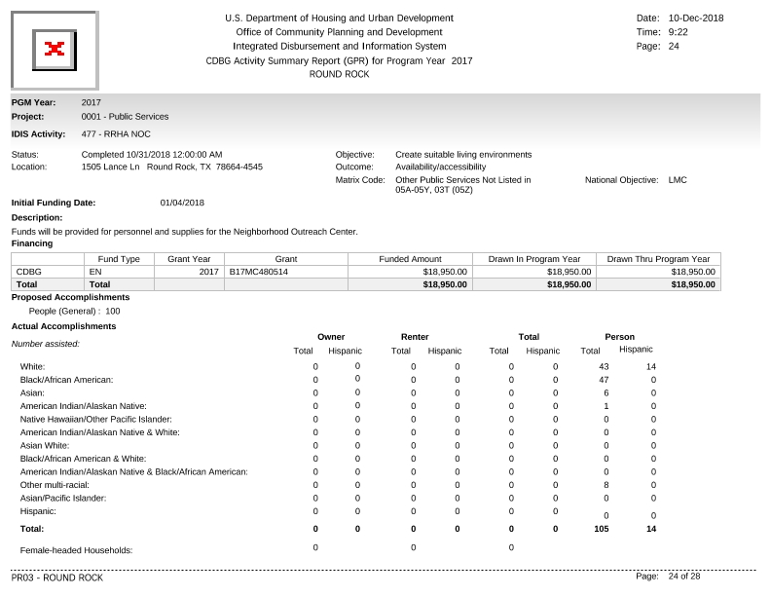
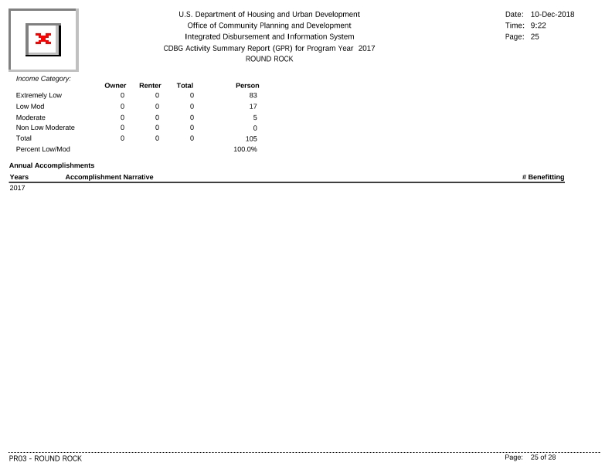
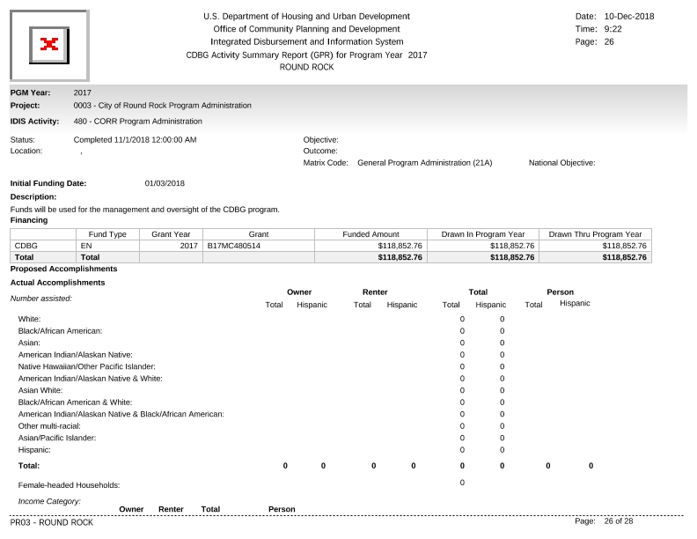
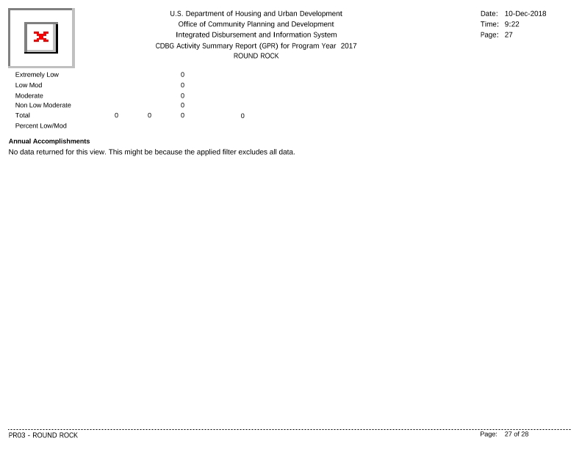
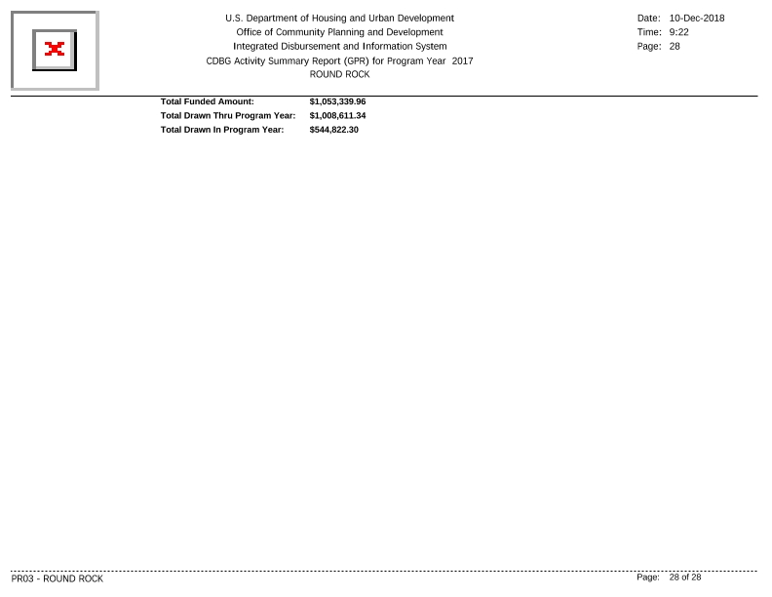

LOCCS Report, PR26, PR07
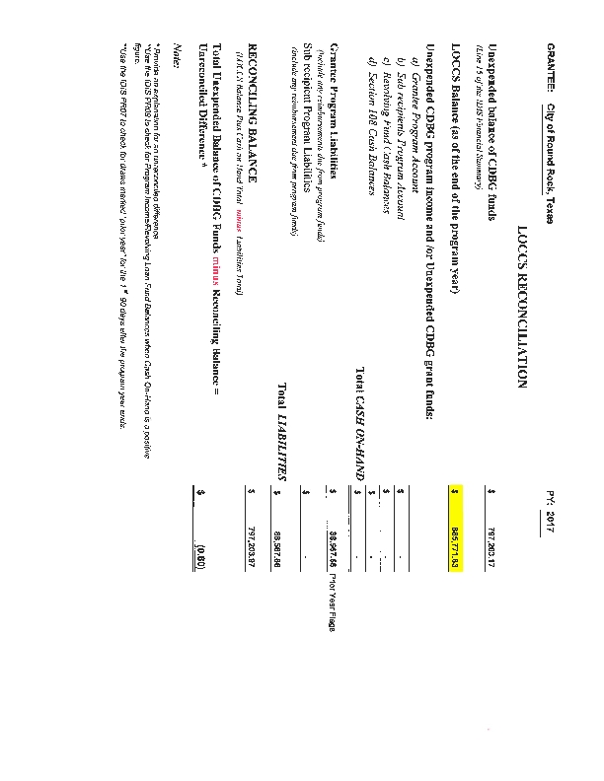
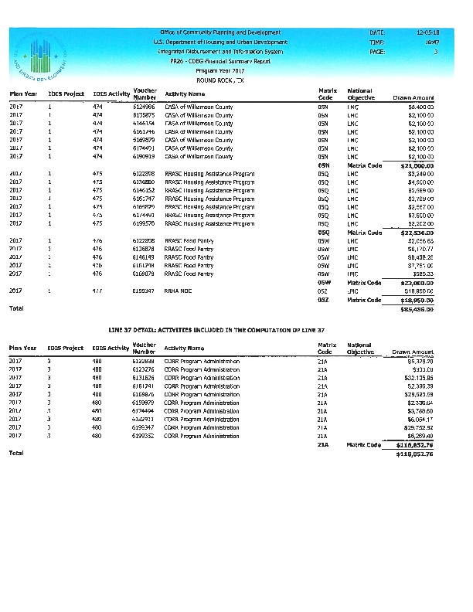
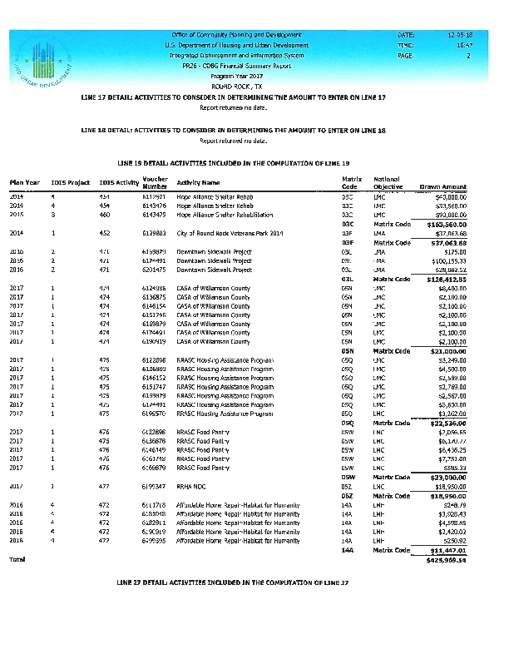
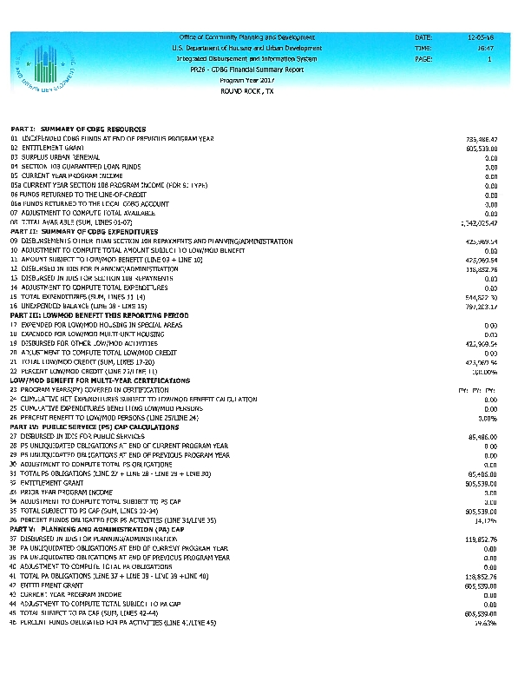
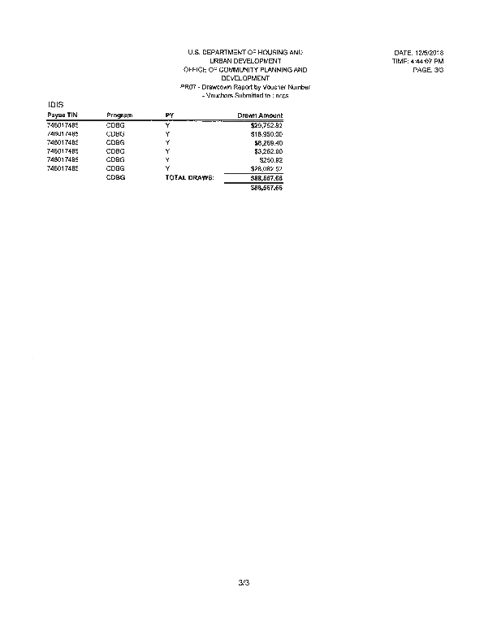
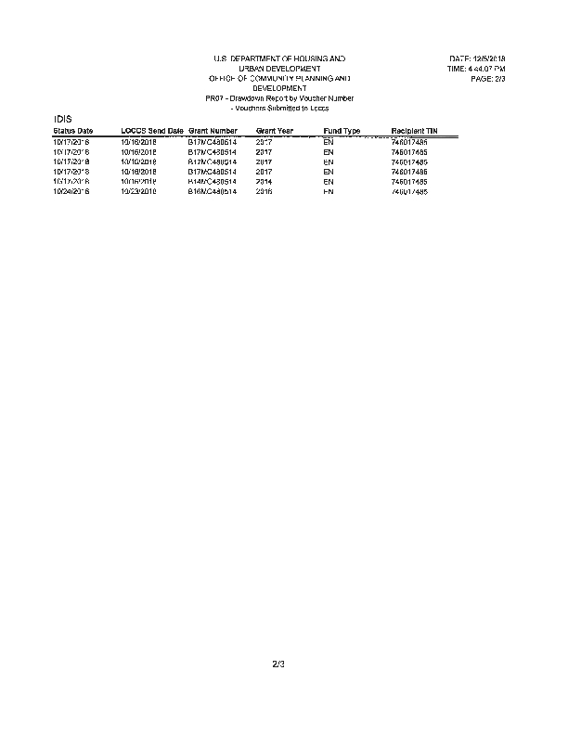
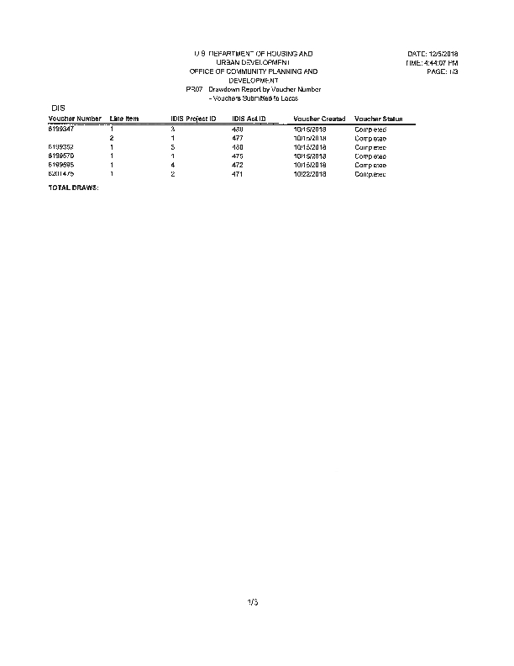

CAPER Public Notices and Proof of Publication
